This document records the differences that have been observed while migrating simulation for ExpertOp4Grid from Pypownet to Grid2op. 2 cases are considered to verify that ExpertOp4Grid works with Grid2op backend. We find some differences between Pypownet and Grid2op but they have been explained and validated

* **Case 1 :**

|  |  |  |  |  |  |
| --- | --- | --- | --- | --- | --- |
|  | Line to cut | CapacitY line (A) | réseau | THRESHOLD worsened lines | THRESHOLD score 2 |
| Pypownet | 9 | 240 | Default_14_static | 5% | 30% |
| grid2op | 9 | 230 | L2rpn_2019 | 5% | 30% |

Pypownet :

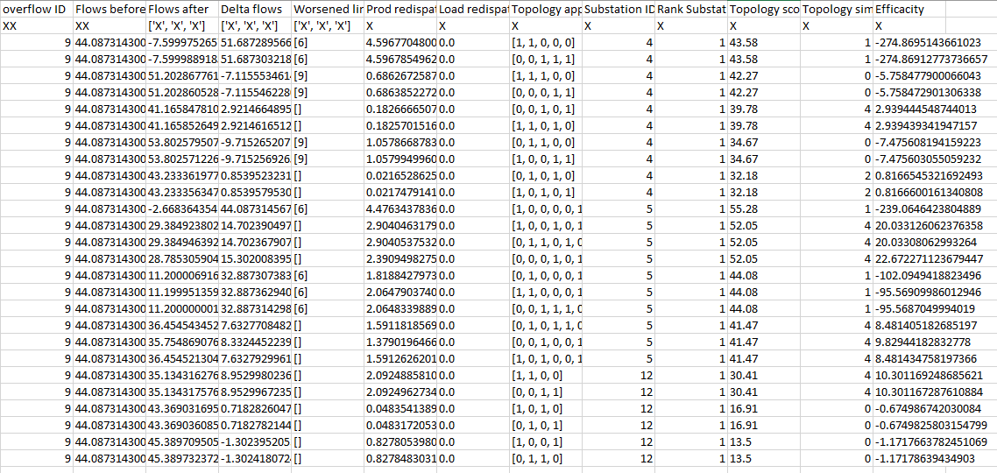

Grid2op :

Difference between scores : theshold effect in computation of score 2 (30%)

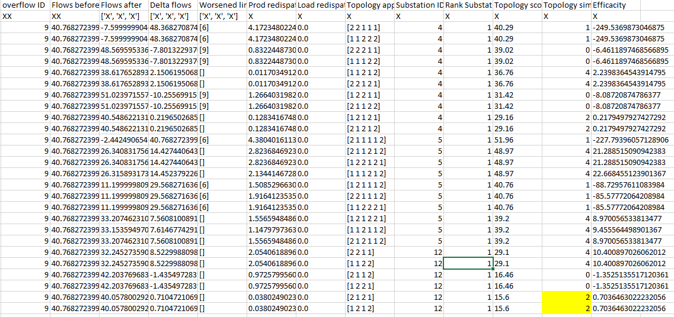

* **Case 2 :**

|  |  |  |  |  |  |
| --- | --- | --- | --- | --- | --- |
|  | Line to cut | CapacitY line (A) | réseau | THRESHOLD worsened lines | THRESHOLD score 2 |
| Pypownet | 8 | 88 | Default_14_static | 5% | 30% |
| grid2op | 8 | 88 | L2rpn_2019 | 5% | 30% |

Pypownet :

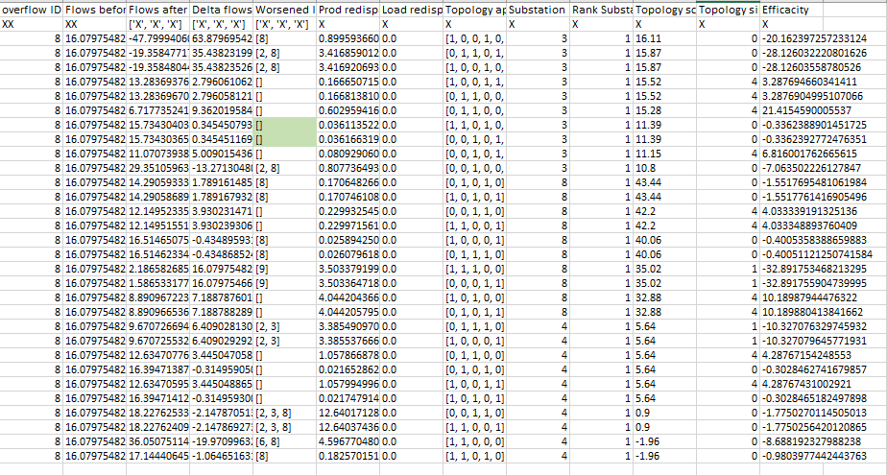

Grid2op :

Difference between worsened lines : threshold effect (5%)

Différence between scores : we verified that the overflow is solved in grid2op (see graph plots below)

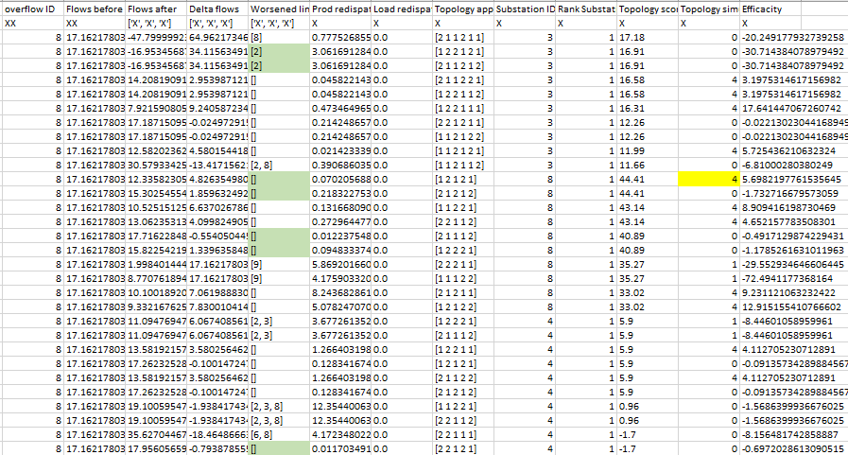

Avant application de la topo 1,2,1,2,1 sur la substation 8 : ligne 8 en overflow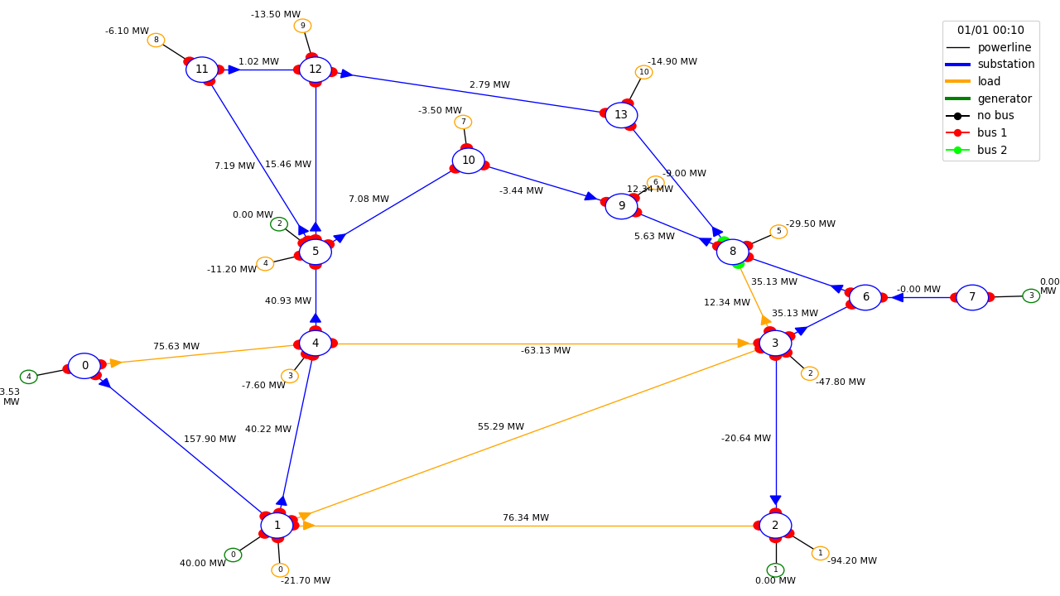

Après application de la topo 1,2,1,2,1 sur la substation 8 : overflow résolu

